**CS G526 – Advanced Algorithms and Complexity**

**Lab-2**

**Problem 1:**

Given a binary tree, find the lowest common ancestor (LCA) of two given nodes in the tree. The lowest common ancestor is defined between two nodes p and q as the lowest node in T that has both p and q as descendants (where we allow **a node to be a descendant of itself**).

**Example 1:**

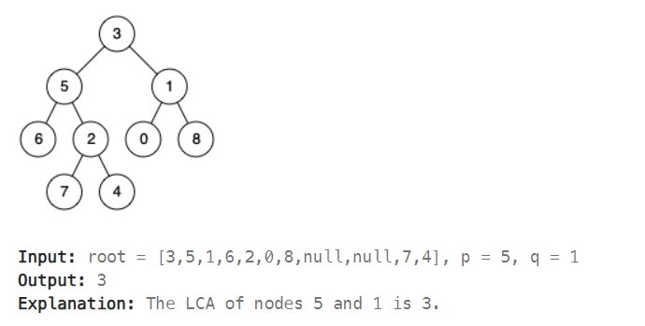

**Example 2:**

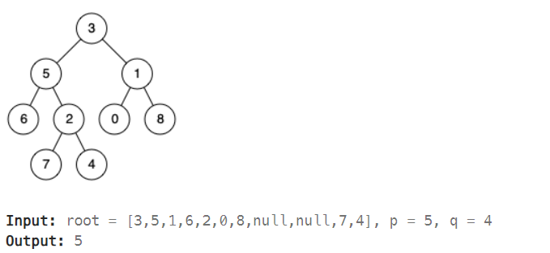

**Problem 2:**

Find lowest common ancestor of two given nodes in a **binary search tree.**

**Example 1:**

